Welcome
About You |  |  |  |  |  |  |  |  |  |  |  |  |  |  |  |  |  | Todays Date:
Name:
 |  |  |  |  |  |  | Last |  |  |  |  |  |  |  |  |  |  |  |  |  |  | First (Full) |  |  |  |  |  |  |  |  |  |  |  | M.I.
Male |  |  |  | Female |  |  |  |  |  |  |  |  |  |  |  | Nickname:
Birthdate |  |  |  |  |  |  |  |  |  |  |  |  |  |  | Age |  |  |  |  |  |  |  |  |  | SS#* |  |  | - -
Mailing Address |  |  |  |  |  |  |  |  |  |  |  |  |  |  |  |  |  |  |  |  |  |  |  |  |  |  |  |  |  |  | Apartment
City |  |  |  |  |  |  |  |  |  |  |  | State |  |  |  |  |  |  |  |  |  |  | Zip Code
Primary Phone |  |  |  |  |  |  |  |  |  |  |  | Work Phone |  |  |  |  |  |  |  |  |  |  |  |  |  |  |  |  | Other
Email Address
Occupation
Employer |  |  |  |  |  |  |  |  |  |  |  |  |  |  |  |  |  |  |  |  |  |  |  |  |  | How Long?
Emergency Contact
Emergency #
Who may we thank for your referral?
Have you been to a chiropractor in the past? |  |  |  |  |  |  |  |  |  |  |  |  |  |  | Yes No

Your Health History
Date of last known exam:
Physical Exam |  | Spinal X-Ray
Spinal Exam |  | MRI, CT or Bone Scan

Place a check mark next to any of the following that apply to you:
AIDS/HIV |  | Gout |  | Pinched Nerve
Allergies |  | Heart Disease |  | Polio
Anemia |  | Hepatitis |  | Prostate Issues
Arthritis |  | Hernia |  | Rheum. Arthritis
Asthma |  | Herniated Disk |  | Sinus Condition
Backaches |  | Migraine Headaches |  | Stroke
Cancer |  | Other Headaches |  | Thyroid Issues
Concussion |  | Multiple Sclerosis |  | Tuberculosis
Diabetes |  | Muscular Dystrophy |  | Tumors
Digestive Disorder |  | Neuritis |  | Ulcers
Dizziness/Vertigo |  | Numbness |  | Other
Emphysema |  | Osteoporosis
Epilepsy |  | Pacemaker
Fractures |  | Parkinson’s Disease
EXERCISE |  | WORK ACTIVITY |  | HABITS
None |  | Sitting |  | Smoking/Vaping/Nicotine |  |  |  | Packs/Day
Moderate |  | Standing |  | Alcohol |  |  |  | Drinks/Week
Daily |  | Light Labor |  | Coffee/Caffeine Drinks |  |  |  | Cups/Day
Heavy |  | Heavy Labor |  | High Stress |  |  |  | Reason
Are you pregnant? |  |  | Yes No |  | Due Date
Please describe any injuries or surgeries you have had:

Back →

Your Concerns
What is your major complaint or concern?
When did your symptoms appear?
Are your symptoms constant? |  |  |  |  |  | coming and going? |  |  |  |  |  |  |  |  |  | getting worse? |  |  |  |  |  |  | getting better?
What treatment have you already received for your condition? |  |  |  |  |  |  |  |  |  |  |  |  |  |  |  | Medications |  |  |  |  |  |  |  |  | Surgery
Physical Therapy |  |  |  | Chiropractic |  |  |  |  |  | None |  |  |  |  |  |  |  |  | Other
Other doctor(s) that treated you for this condition:
*Rate the severity of your pain on a scale from 1 (least pain) to 10 (most pain)
Check type of pain:
Sharp |  | Dull |  |  |  |  | Throbbing |  |  |  |  |  |  |  | Aching |  |  |  |  | Shooting
Burning |  | Numbness |  |  |  |  | Tingling |  |  |  |  |  |  |  | Stiffness |  |  |  |  | Other
Place circles around the area(s) of discomfort
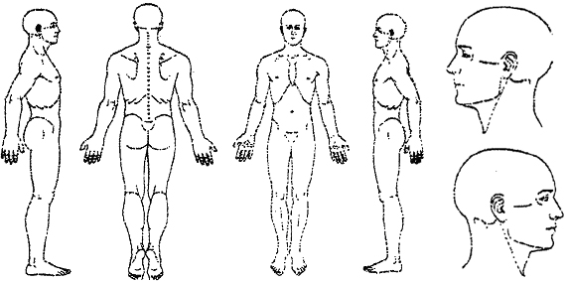
R
R
R
L
L
L
R
L

How often do you have this pain?
Does it interfere with |  |  |  |  | Work |  |  |  |  |  |  | Sleep |  |  |  |  | Daily Routine |  |  |  |  | Recreation
Activities or movements that are painful to perform:
Sitting |  |  | Standing |  |  |  |  |  | Walking |  |  |  |  |  |  |  |  | Bending |  |  |  |  |  |  |  | Lying Down
Who else have you seen for this problem?
Other comments or concerns regarding your condition:

I understand and agree that health and accident insurance policies are an arrangement between an insurance carrier and myself. Furthermore, I understand that this office will prepare any necessary reports and forms to assist me in making collection from the insurance company and that any amount authorized to be paid directly to this office will be credited to my account upon receipt. I clearly understand and agree that all services rendered me are charged directly to me and that I am personally responsible for payment. I also understand that if I suspend or terminate my care and treatment, any fees for professional services rendered me will be immediately due and payable.

Patient Signature |  | Date
If patient is under 18:
Guardian Signature |  | Date

